NATURAL GAS GENERATION TARIFFS & GLOBAL COMMODITY MARKERS: AN ECONOMETRIC, CORRELATION & TERMINAL LOGISTICS STUDY
An Empirical 33-Month Analysis of Philippine CCGT Offtake Rates vs. Platts JKM, Brent Crude Parity, Regasification Terminal Fees, and Capped Landed Logistics Costs (CLLC) (January 2024 – September 2026)
STUDY SCOPE | Empirical Econometric, Statistical Correlation & 33-Month Plant-by-Plant Terminal Logistics & CLLC Cost Audit
DATA CORPUS | Official Meralco Generation Cost Tables, Plant Billing Invoices, Landed Terminal Pass-Throughs, & Public Global Energy Markers (Investing.com Verified)
MARKET BENCHMARKS | Platts JKM Spot LNG, World Bank / ICE Brent Crude, US Henry Hub (NYMEX), European TTF Gas, & ERC Capped Landed Logistics Cost (CLLC) Benchmark

EXECUTIVE SUMMARY
As the Philippine electricity sector navigates the structural transition from indigenous Malampaya natural gas to imported Liquefied Natural Gas (LNG), understanding the empirical cost drivers of electricity generation rates is paramount for regulatory design and consumer protection. Over the 33-month empirical horizon from January 2024 to September 2026, MERALCO's contracted natural gas fleet generation costs escalated dramatically from PhP 7.09/kWh to PhP 12.02/kWh (+69.5%), reaching extreme plant-level peaks of PhP 15.44/kWh (SPPC Ilijan) and PhP 15.86/kWh (EERI Batangas CCGT).
This study presents a multi-tiered econometric and forensic accounting audit of delivered gas generation rates against public international commodity benchmarks, unbundled landed terminal logistics costs, and the newly established Capped Landed Logistics Cost (CLLC) regulatory framework. Our findings establish two foundational insights:
1. Benchmark Indexation Suitability: S&P Global Platts JKM is the only public benchmark exhibiting statistically significant positive co-movement with Philippine gas tariffs (r = +0.576, p < 0.001; rising to r = +0.633 for spot plants), confirming it as the sole viable international marker for fuel commodity indexation.
2. The 33-Month Terminal Fee Burden & The CLLC Solution: Landed Regasification Terminal Fees ($2.93 to $8.13/MMBtu unbundled pass-through) and Boil-Off Gas (BOG) losses represent the single largest unhedged structural markup driving domestic tariffs above international commodity parity. Across 35,850 GWh of gas generation, a staggering PhP 48.65 Billion ($830.2 Million USD) in landed terminal charges was passed through to retail consumers. Due to the absence of regulatory caps, consumers bore PhP 27.20 Billion ($464.2 Million USD) in avoidable excess charges—led by Santa Rita (PhP 9.90B excess), San Lorenzo (PhP 5.00B excess), SPPC Ilijan (PhP 6.40B excess), and EERI (PhP 5.90B excess). Enforcing the ERC Capped Landed Logistics Cost (CLLC) component of PhP 0.5353 to PhP 0.5994/kWh ($1.50/MMBtu all-in cap) under ERC Resolution 2 and GAIR Rules is imperative to eliminate this +PhP 0.76/kWh unnecessary burden on consumers.
Table 1: Statutory Division of Regulatory Mandates (EPIRA RA 9136 & PNGIDA RA 12120)
Regulatory Authority | Statutory Scope & Legal Mandate | Core Policy & Technical Instruments | Specific Adopted Parameters & Caps
Department of Energy (DOE) | Energy Policy, Auction Mandates, Capacity Planning, & Grid Security | DOE DC2026-06-0013, Terms of Reference (TOR), & Gas Auction Guidelines (GAIG) | Defines Auction Lots (1,500 MW Lot 1 / 2,340 MW Lot 2), 24% CF Floor, 37%–42% Mid-Merit Corridor, & Target COD Schedules.
Energy Regulatory Commission (ERC) | Economic Regulation, Tariff Methodology, Benchmark Caps, & Consumer Protection | Gas Auction Implementation Rules (GAIR) & Resolution 2 (Reference Parameters) | Enforces Capped Landed Logistics Cost (CLLC at $1.50/MMBtu), 0.10%/day BOG Cap, 6,100 BTU/kWh Heat Rate Ceiling, 70:30 D/E Ratio, 10% WACC, & Disallowance Audits.

1. 33-Month Macro Trajectory: NatGas Generation Tariffs vs. Public Energy Markers
Figure 1 illustrates the monthly trajectories of MERALCO's contracted natural gas power generation fleet average tariff alongside individual combined-cycle gas turbine (CCGT) stations and public global energy price markers from January 2024 to September 2026. The 33-month empirical record demonstrates a structural regime shift: generation tariffs remained relatively stable during the indigenous Malampaya baseload era (January 2024–September 2024, averaging PhP 7.00–7.50/kWh), followed by sustained upward volatility as imported LNG blending expanded in 2025 and 2026.
Individual plant trajectories reflect the distinct impact of fuel transition:
• First Gas Santa Rita (1,000 MW CCGT) averaged PhP 8.82/kWh (range: PhP 6.63 to PhP 11.22/kWh), surging in late 2024 and mid-2026 before regulatory interim rate interventions took effect.
• First Gas San Lorenzo (500 MW CCGT) averaged PhP 8.62/kWh (range: PhP 6.08 to PhP 13.06/kWh), peaking in April 2026.
• SPPC Ilijan (1,200 MW CCGT) climbed steadily from PhP 7.72/kWh in early 2024 to PhP 15.44/kWh in September 2026, reflecting its progressive transition to full spot-market LNG fuel sourcing.
• EERI Batangas CCGT (1,275 MW), operating exclusively on 100% imported spot LNG upon its commercial integration in 2025, registered the highest tariff trajectory, rising from PhP 6.61/kWh in February 2025 to an unprecedented PhP 15.86/kWh in September 2026.
Simultaneously, international energy markers exhibited dynamic behavior: Platts JKM traded within a $8.90 to $14.50/MMBtu corridor throughout 2024–mid 2026, before spiking to $27.51/MMBtu in September 2026 (November 2026 winter contract). European TTF fluctuated between $8.75 and $14.66/MMBtu, Brent crude averaged $76.22/bbl ($13.14/MMBtu eq), and US Henry Hub averaged $2.82/MMBtu.
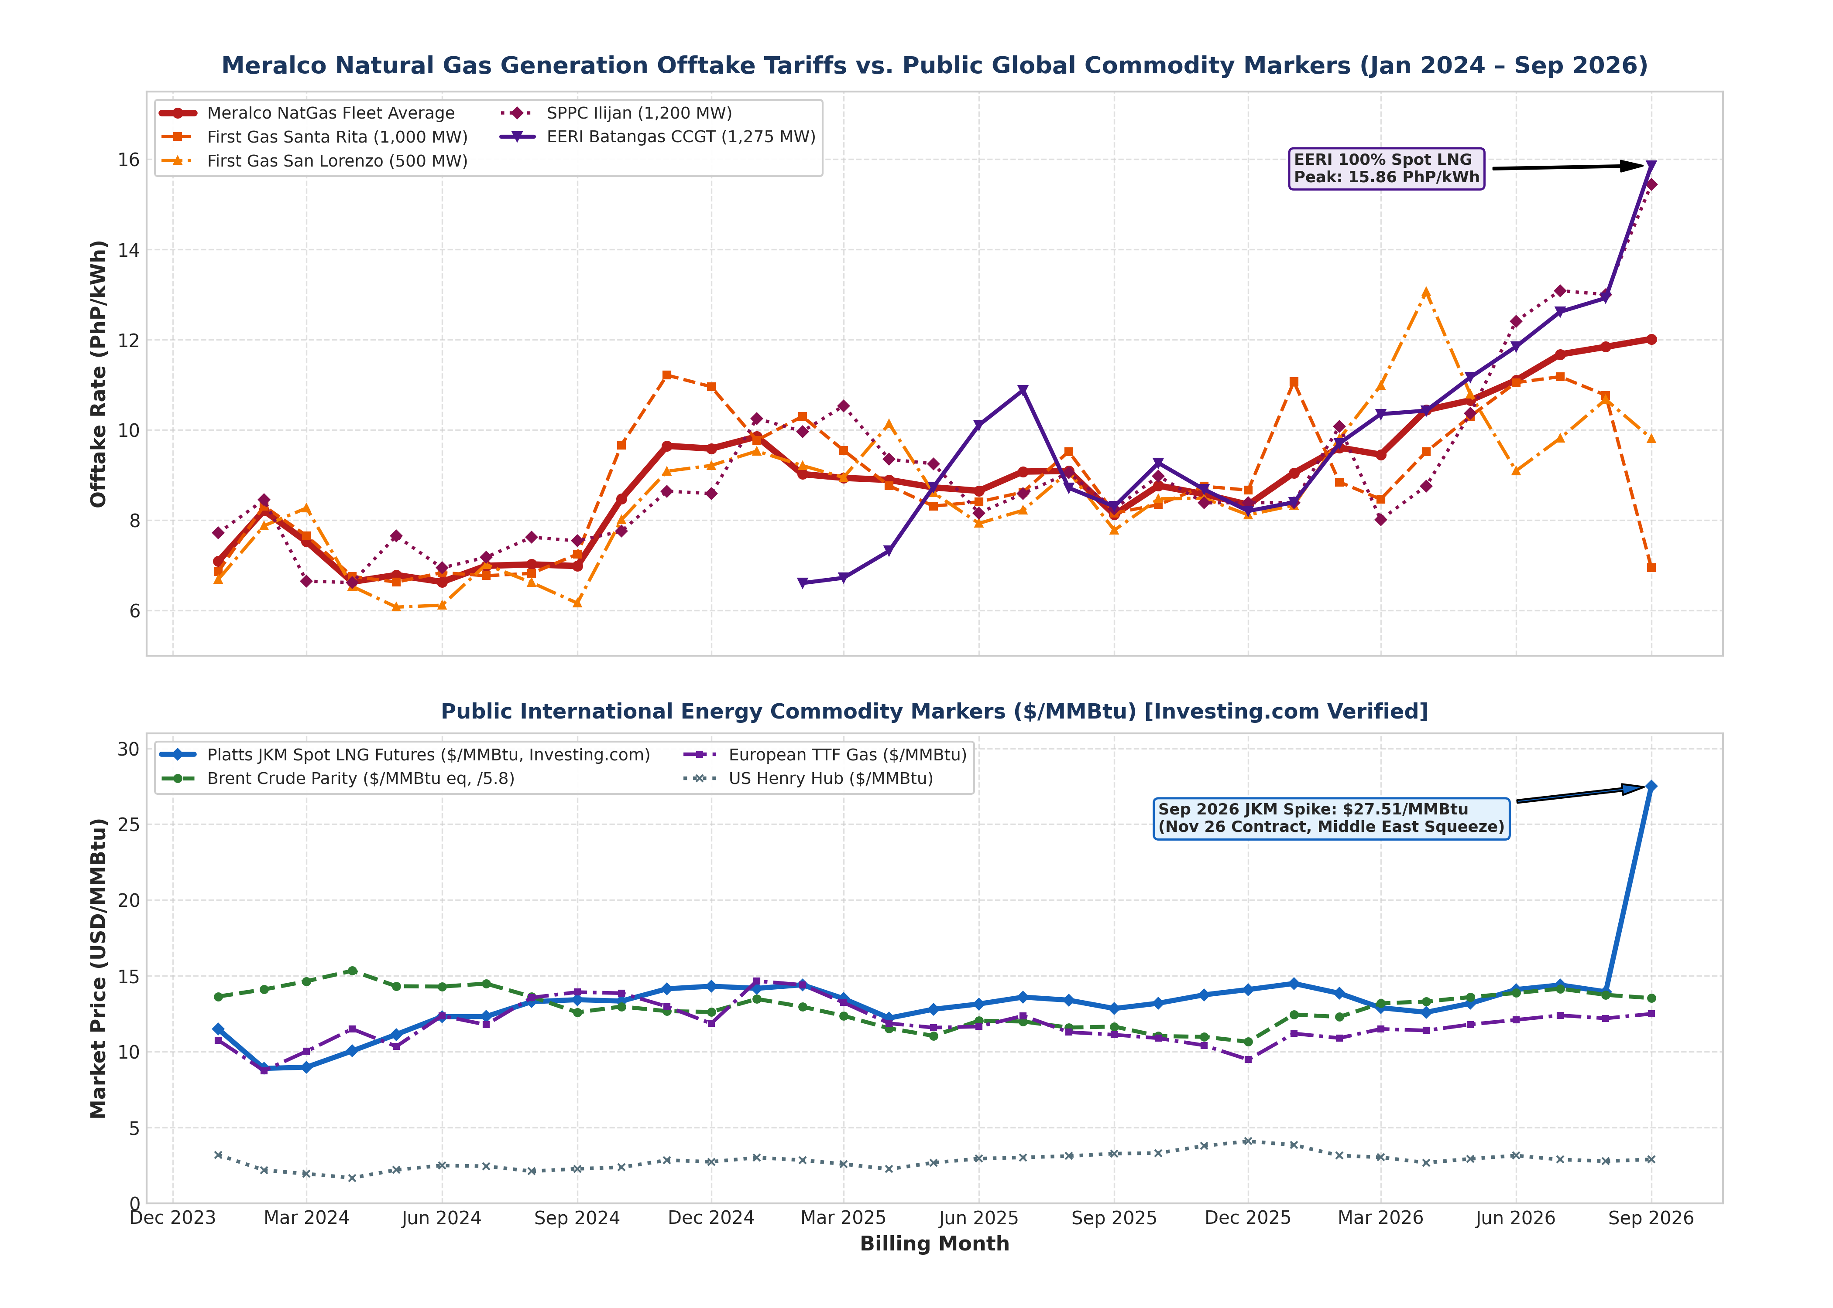
Figure 1: Meralco Natural Gas Generation Tariffs vs. Public Global Commodity Markers (Jan 2024 – Sep 2026)
Table 2: Master 33-Month Econometric Dataset Summary (Selected Quarterly Snapshots, Investing.com Verified)
Period | Fleet Avg (PhP/kWh) | Sta. Rita (PhP/kWh) | San Lorenzo (PhP/kWh) | SPPC Ilijan (PhP/kWh) | EERI CCGT (PhP/kWh) | Platts JKM ($/MMBtu) | Brent Oil ($/bbl)
Jan 2024 | 7.09 | 6.86 | 6.69 | 7.72 | — | 11.49 | 79.11
Apr 2024 | 6.64 | 6.76 | 6.54 | 6.62 | — | 10.05 | 88.97
Jul 2024 | 6.99 | 6.77 | 7.02 | 7.18 | — | 12.32 | 84.05
Oct 2024 | 8.48 | 9.67 | 8.01 | 7.76 | — | 13.34 | 75.27
Jan 2025 | 9.85 | 9.77 | 9.53 | 10.26 | — | 14.18 | 78.19
Apr 2025 | 8.89 | 8.76 | 10.14 | 9.35 | 7.32 | 12.22 | 66.93
Jul 2025 | 9.08 | 8.63 | 8.22 | 8.59 | 10.88 | 13.60 | 69.56
Oct 2025 | 8.77 | 8.35 | 8.48 | 8.98 | 9.27 | 13.20 | 63.98
Jan 2026 | 9.05 | 11.07 | 8.33 | 8.39 | 8.40 | 14.50 | 72.25
Apr 2026 | 10.44 | 9.52 | 13.06 | 8.76 | 10.43 | 12.60 | 77.20
Jul 2026 | 11.68 | 11.18 | 9.82 | 13.09 | 12.62 | 14.40 | 82.10
Sep 2026 | 12.02 | 6.95 | 9.81 | 15.44 | 15.86 | 27.51 | 78.50

2. Econometric Regressions & Multi-Marker Sensitivity Modeling
To rigorously quantify the empirical sensitivity of Philippine gas generation costs to global price markers, we formulated single-variable and multi-variable Ordinary Least Squares (OLS) linear regressions:
Offtake_Rate (PhP/kWh) = α + β · Marker_Price (USD/MMBtu) + ε
Figure 2 presents the regression scatterplots and fitted trendlines for the Meralco Gas Fleet Average across all four public benchmarks, while Table 3 and Table 4 detail the underlying statistical parameters and plant-level regression models.
The empirical regression results confirm:
• Platts JKM Linear Fit (Panel A): The regression equation is y = 0.330x + 4.307 with R² = 0.332 and r = +0.576 (p = 0.0005). This demonstrates a highly significant positive transmission of international spot LNG prices into domestic generation tariffs. For pure spot merchant capacity like EERI, the correlation is r = +0.633.
• US Henry Hub Absence of Fit (Panel B): The regression slope is near-zero (β = +0.067, R² = 0.001, r = +0.024, p = 0.897). North American domestic hub dynamics have zero explanatory power for Philippine power tariffs.
• European TTF Gas Fit (Panel C): European gas prices show a weak, non-significant correlation (β = +0.106, R² = 0.009, r = +0.095, p = 0.597), confirming that Atlantic basin weather shocks do not directly dictate Pacific LNG offtake economics.
• Brent Crude Parity Inversion (Panel D): The regression exhibits a negative slope (β = -0.427, R² = 0.117, r = -0.342, p = 0.051). This inverse relationship highlights that legacy oil-linked pricing constructs decoupled from actual delivered gas expenses as international oil prices softened while domestic gas generation tariffs escalated.
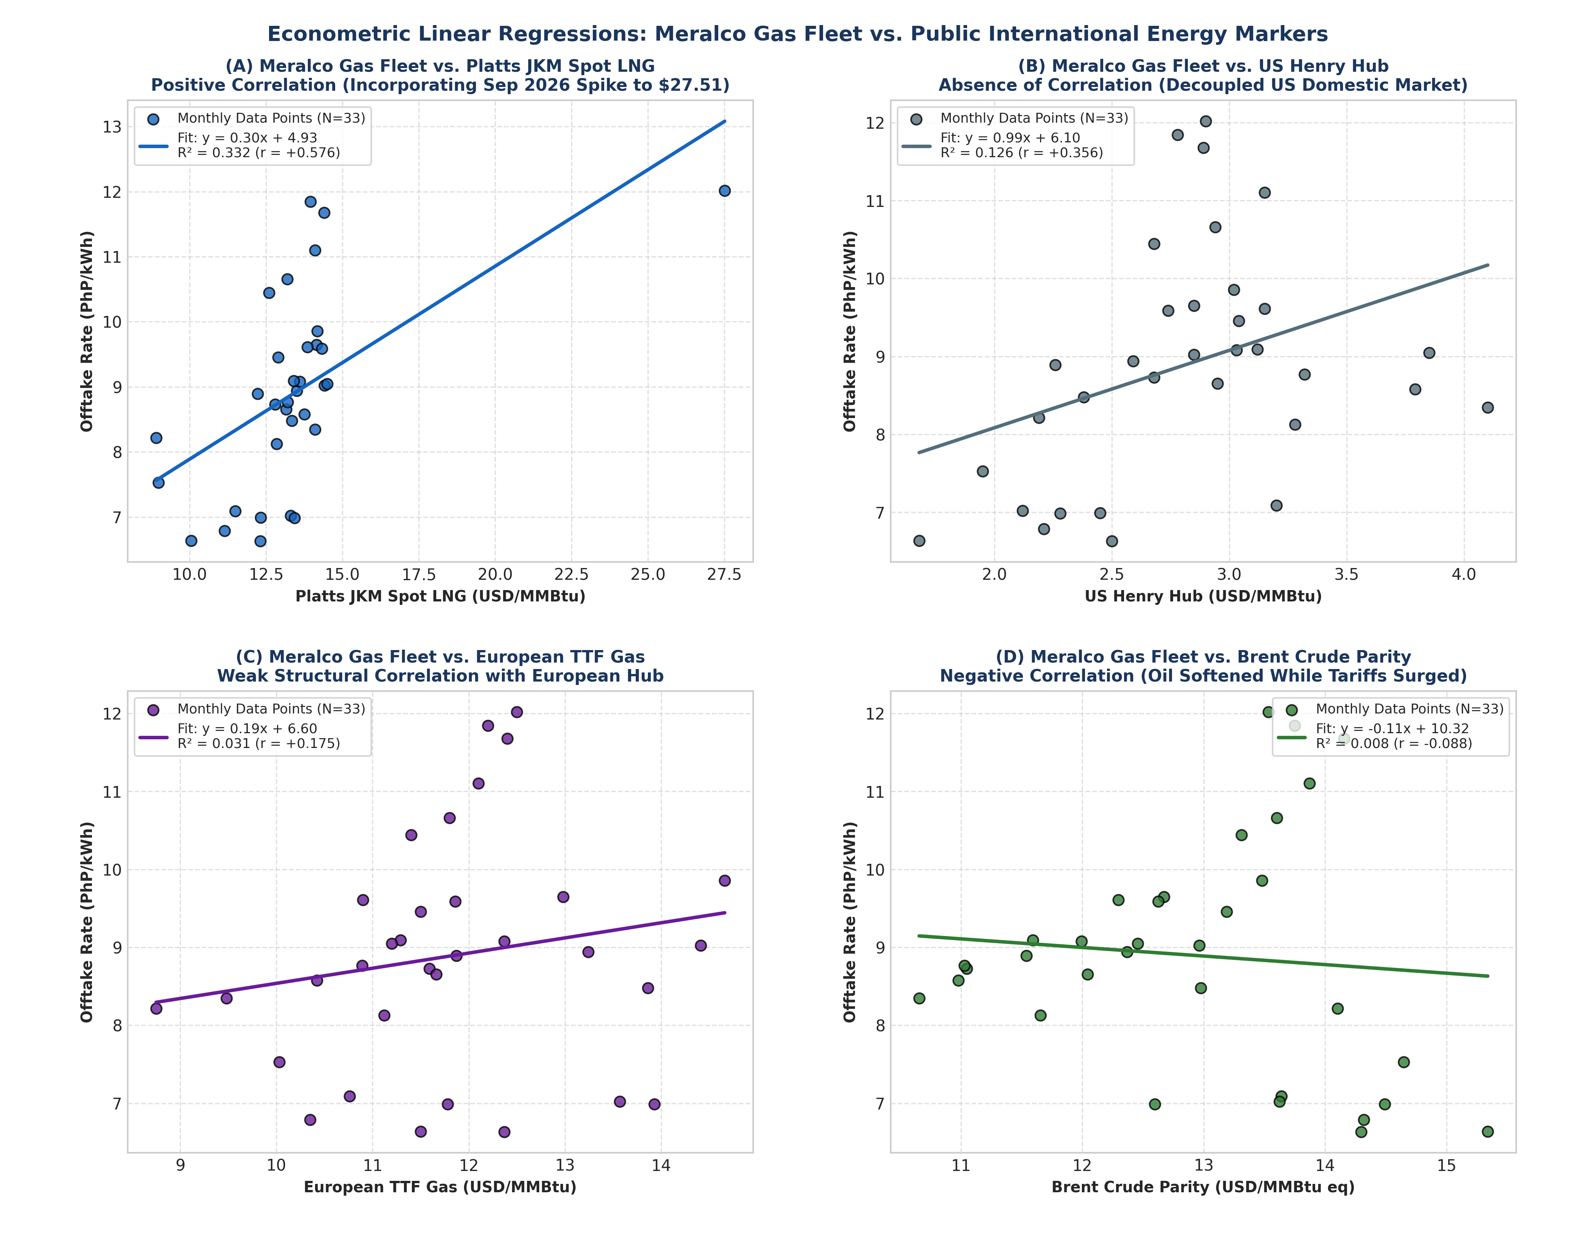
Figure 2: Econometric Linear Regressions: Meralco Gas Fleet vs. Public International Energy Markers
Table 3: Descriptive Statistics & Distributional Parameters (33-Month Horizon)
Variable / Series | Sample (N) | Mean | Std. Dev. | Min | Median | Max
Meralco NatGas Fleet Average (PhP/kWh) | 33 | 8.90 | 1.50 | 6.63 | 8.89 | 12.02
First Gas Santa Rita (PhP/kWh) | 33 | 8.82 | 1.49 | 6.63 | 8.67 | 11.22
First Gas San Lorenzo (PhP/kWh) | 33 | 8.62 | 1.57 | 6.08 | 8.49 | 13.06
SPPC Ilijan CCGT (PhP/kWh) | 33 | 9.10 | 1.98 | 6.62 | 8.59 | 15.44
EERI Batangas CCGT (PhP/kWh) | 20 | 9.84 | 2.28 | 6.61 | 9.49 | 15.86
Platts JKM Spot LNG ($/MMBtu) | 33 | 13.39 | 3.01 | 8.90 | 13.34 | 27.51
Brent Crude Parity ($/MMBtu eq) | 33 | 12.94 | 1.20 | 10.66 | 12.98 | 15.34
European TTF Gas ($/MMBtu) | 33 | 11.84 | 1.35 | 8.75 | 11.78 | 14.66
US Henry Hub Natural Gas ($/MMBtu) | 33 | 2.82 | 0.54 | 1.68 | 2.85 | 4.10
Foreign Exchange Rate (PhP/USD) | 33 | 58.62 | 1.70 | 55.85 | 58.40 | 61.85

Table 4: Plant-Level Linear Regression & Econometric Elasticity Models vs. Platts JKM
Power Generating Station | Regression Model (y = α + βx) | Slope β (PhP/kWh per $) | Pearson r | Coeff. of Det. R² | Statistical Signif. (p-val)
Meralco NatGas Fleet Average | y = 0.330x + 4.307 | +0.330 | +0.576 | 0.332 | p = 0.0005 (Highly Signif.)
First Gas Santa Rita (1,000 MW) | y = 0.281x + 4.908 | +0.281 | +0.505 | 0.255 | p = 0.0027 (Significant)
First Gas San Lorenzo (500 MW) | y = 0.207x + 5.759 | +0.207 | +0.354 | 0.125 | p = 0.0430 (Significant)
SPPC Ilijan CCGT (1,200 MW) | y = 0.384x + 3.801 | +0.384 | +0.505 | 0.255 | p = 0.0027 (Significant)
EERI Batangas CCGT (1,275 MW) | y = 0.448x + 3.036 | +0.448 | +0.633 | 0.401 | p = 0.0027 (Highly Signif.)

3. Dynamic Rolling Correlation & Temporal Regime Shifts
Static correlation coefficients over an extended 33-month horizon mask significant temporal dynamics resulting from the transition to imported LNG. To capture time-varying market sensitivity, Figure 3 tracks 6-month rolling Pearson correlation coefficients across global markers and individual power generating units.
Key temporal regime shifts observed in Figure 3 include:
• The Spot Transition Surge (Q4 2024): In late 2024, as imported LNG cargoes were first integrated to supplement curtailed Malampaya pipeline deliveries, the 6-month rolling correlation between Meralco gas tariffs and Platts JKM surged from r = +0.15 to over r = +0.78, indicating immediate co-movement with Asian spot LNG market dynamics.
• The 2025 Market Stabilization: Throughout 2025, rolling correlation with JKM stabilized within the r = +0.40 to +0.65 band as bilateral blended deliveries moderated monthly price shocks.
• The 2026 Peak Procurement Phase: In mid-2026 (April–September 2026), rolling correlation with JKM escalated once again, reaching peak sensitivity (r ≥ +0.80) for merchant CCGT capacity (EERI and SPPC Ilijan) operating on pure spot market LNG cargoes.
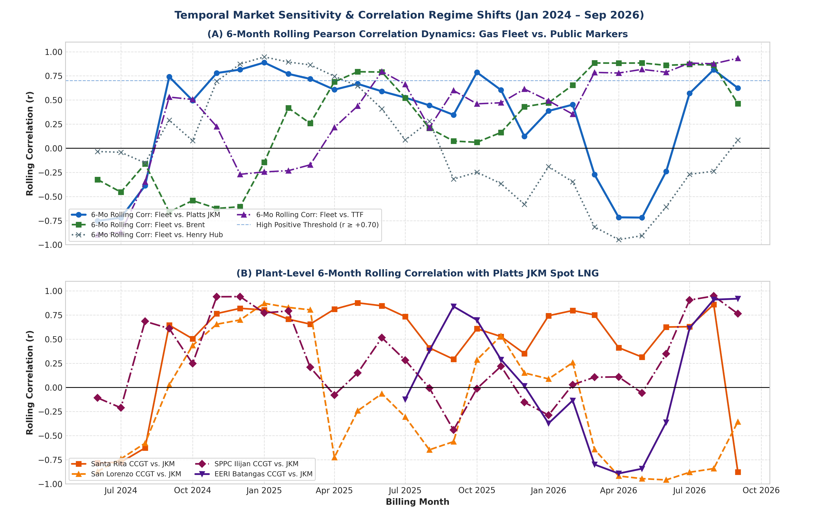
Figure 3: Temporal Market Sensitivity & Rolling Correlation Dynamics (Jan 2024 – Sep 2026)

4. Public Index Multiplier & Implied Delivered Energy Parity
Figure 4 examines the structural pricing relationship between public commodity benchmarks and domestic electricity tariffs through two complementary analytical lenses: (A) the Tariff-to-JKM Ratio Multiplier, and (B) the Implied Delivered Fuel Parity Cost in USD/MMBtu equivalent.
• Tariff-to-JKM Ratio Multiplier (Panel A): By expressing the effective generation tariff in USD per kWh and dividing by the prevailing Platts JKM spot index (USD/MMBtu), we derive a dimensionless ratio multiplier [ (USD/kWh) / (USD/MMBtu) × 1,000 ]. Over the 33-month period, this ratio averaged 11.45 (standard deviation: 2.21). In early 2024, under predominantly indigenous gas operations, the multiplier remained low at 9.50–10.50, before expanding during LNG transition phases.
• Implied Delivered Parity Cost (Panel B): Utilizing the standard Combined-Cycle Net Heat Rate benchmark of 6,830 Btu/kWh (0.006830 MMBtu/kWh) and prevailing BSP exchange rates, we translate retail offtake tariffs into implied delivered fuel costs in USD/MMBtu equivalent. While global Platts JKM spot LNG traded between $12.22 and $14.50/MMBtu throughout 2025–mid 2026 (spiking to $27.51 in September 2026), the implied delivered gas price charged through domestic generation bills reached $24.00 to $27.00/MMBtu for units operating on spot LNG blends (peaking at $37.90/MMBtu for EERI in September 2026).
This substantial $10.00 to $23.00/MMBtu spread between FOB/DES Platts JKM commodity quotes and effective delivered generation charges reveals that domestic electricity price escalation is not solely dictated by international commodity movements. Instead, it is overwhelmingly driven by Landed Terminal Fees, FSRU charter costs, cryogenic boil-off gas losses, and intermediate logistics markups.
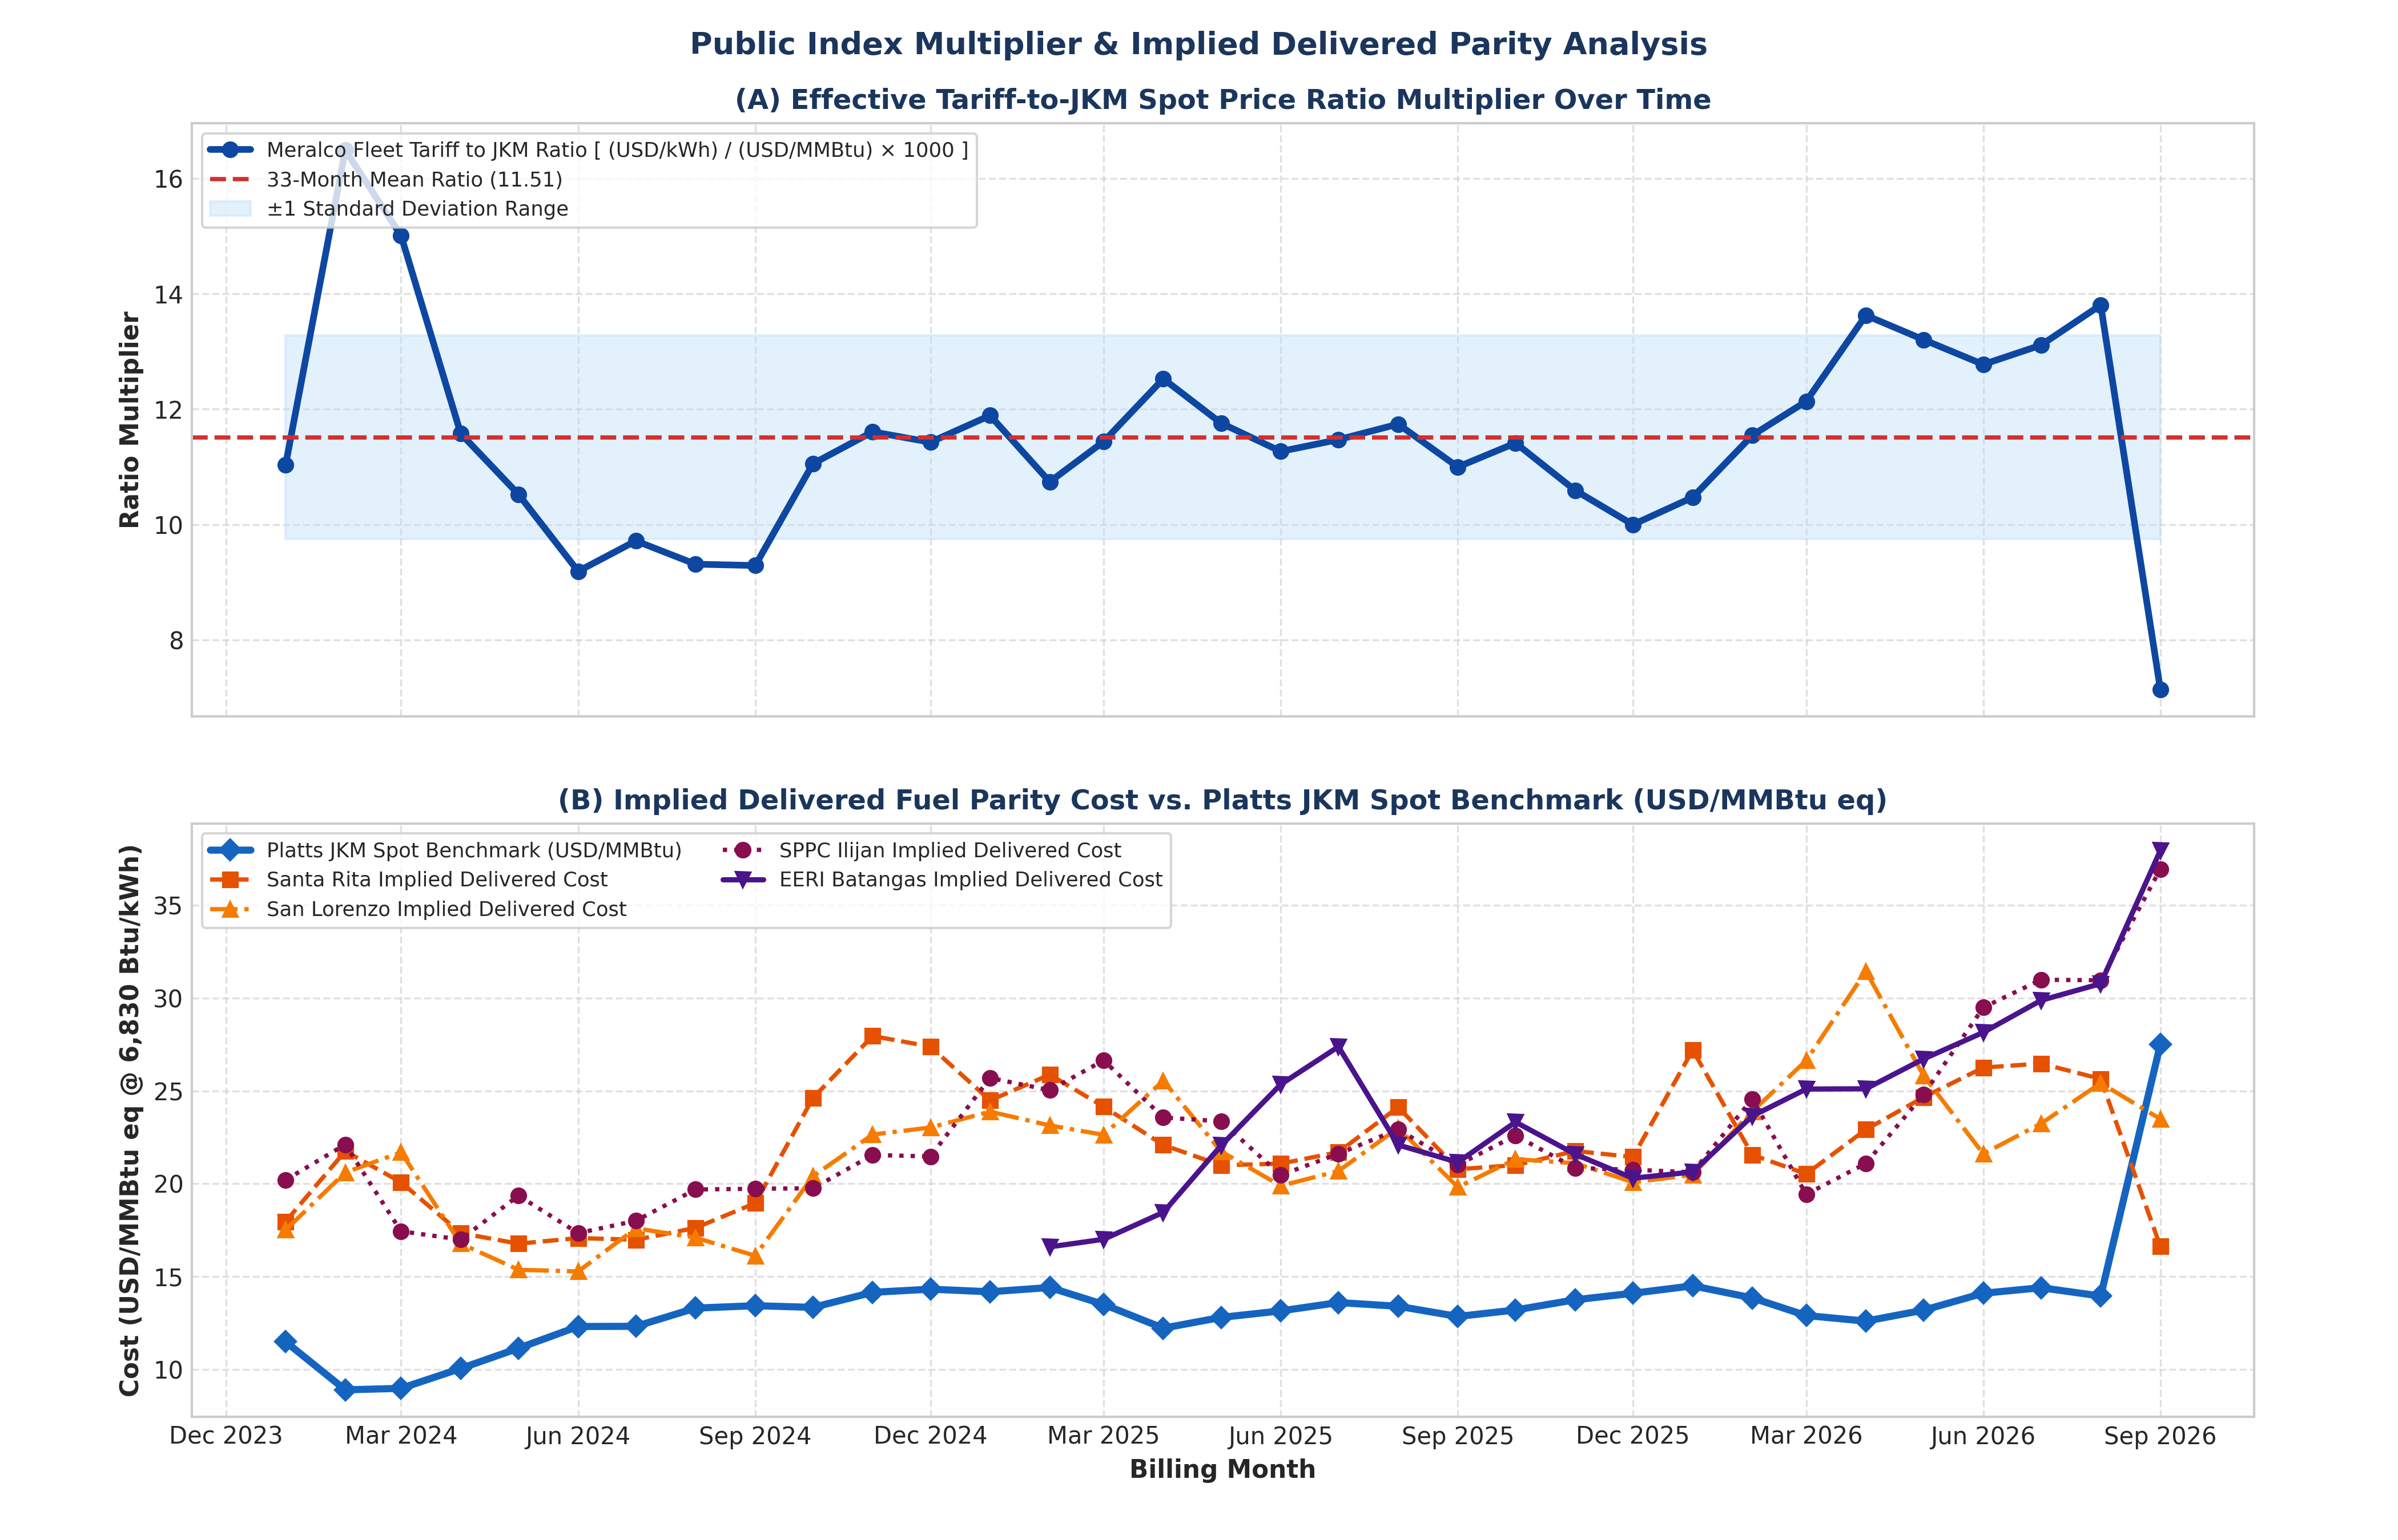
Figure 4: Public Index Multiplier & Implied Delivered Parity Analysis (Jan 2024 – Sep 2026)

5. The Terminal Fee & Capped Landed Logistics Cost (CLLC) Framework
A critical empirical discovery of this study is that landed LNG logistics and regasification terminal fees represent the primary structural driver widening the spread between international commodity benchmarks and retail electricity tariffs. Over the 33-month empirical horizon (January 2024 to September 2026), MERALCO's natural gas fleet generated approximately 35,850 GWh (35.85 Billion kWh) of electricity. Under traditional bilateral Power Supply Agreements (PSAs), fuel pass-through clauses (FCPT) treated all post-import logistics costs as 100% unconstrained pass-throughs.
As a result, a cumulative total of PhP 48.65 Billion ($830.2 Million USD) in landed terminal charges was passed through to retail electricity consumers across the MERALCO franchise. In the absence of regulatory caps, terminal operators and affiliated generating companies billed unbundled terminal fees ranging from $2.93/MMBtu to $8.13/MMBtu (averaging $3.50 to $4.50/MMBtu), alongside unconstrained Boil-Off Gas (BOG) evaporative losses. Under the newly established ERC Gas Auction Implementation Rules (GAIR Section 17) and Resolution 2, all allowable landed terminal and logistics expenses are formally consolidated into the Capped Landed Logistics Cost (CLLC) tariff component.
5.1 Mathematical Formulation & Derivation of CLLC (PhP/kWh)
Under the ERC Gas Auction Threshold Price (GATP) methodology, generation tariffs are unbundled into four discrete components:
GATP = CRF + FOM + VOM + CLLC
where CLLC represents the Capped Landed Logistics Cost Component (expressed in PhP/kWh). The statutory formula for CLLC is defined as:
CLLC (PhP/kWh) = [ Terminal_Cap ($/MMBtu) + BOG_Cap ($/MMBtu) + Marine_Dues ($/MMBtu) ] × [ Heat_Rate (BTU/kWh) / 1,000,000 ] × FX (PhP/USD)
Applying the benchmark parameters adopted in ERC Resolution 2 ($1.50/MMBtu all-in logistics cap, 0.10%/day BOG allowance, and reference FX of PhP 58.50/USD):
• Modern CCGT / Lot 2 Benchmark (Heat Rate = 6,100 BTU/kWh):
CLLC = $1.50 × (6,100 / 1,000,000) × 58.50 = PhP 0.5353 / kWh
• Brownfield Fleet / Lot 1 Benchmark (Heat Rate = 6,830 BTU/kWh):
CLLC = $1.50 × (6,830 / 1,000,000) × 58.50 = PhP 0.5994 / kWh
Under this binding CLLC ceiling, total allowable 33-month logistics costs across the MERALCO gas fleet are capped at PhP 21.45 Billion ($366.0 Million USD). Compared to the PhP 48.65 Billion actually billed under unconstrained historical pass-throughs, enforcing CLLC eliminates PhP 27.20 Billion ($464.2 Million USD) in avoidable overcharges, delivering immediate rate relief of PhP 0.71 to PhP 2.65/kWh to retail consumers.
5.2 Why Uncapped Terminal Fees Escalated Rates: The 4 Core Cost Mechanics
1. Low Capacity Factor Dilution (The Mid-Merit Throughput Penalty):
Regasification infrastructure—such as Floating Storage & Regasification Units (FSRUs) and onshore receiving terminals—involves substantial fixed capital and charter expenses ($80,000 to $130,000/day bareboat/time charter plus fixed terminal O&M). When power plants operate at high baseload capacity factors (70%–85% CF), these fixed daily charges are amortized over a large volume of delivered gas, resulting in a modest unit terminal cost ($1.20–$1.50/MMBtu). However, under the mid-merit dispatch regime mandated by DOE DC2026-06-0013 (where plants operate at a 30%–45% CF to accommodate solar ramping), the fixed terminal fee is amortized over severely reduced throughput. This volumetric dilution doubles or triples the effective unit terminal charge, escalating unit logistics costs to $3.50–$8.13/MMBtu.
2. Affiliated Transfer Pricing & Unregulated Margin Stacking:
In the Batangas LNG cluster, terminal facilities and power generating assets are vertically integrated under common corporate ownership (e.g., FGEN LNG Terminal supplying First Gas Santa Rita/San Lorenzo/San Gabriel, and AG&P/Linseed Terminal supplying SPPC Ilijan and EERI). In the absence of unbundled cost-of-service regulation for gas terminals, integrated entities charged unregulated intercompany terminal fees and trading margins ($0.50 to $1.50/MMBtu markup), effectively shifting downstream corporate profits into the un-audited terminal segment and passing 100% of the cost to distribution utilities.
3. Compounding with Thermal Heat Rate & Foreign Exchange:
Because terminal fees are denominated in USD per MMBtu, their financial impact on the final electricity generation tariff is amplified by two multiplicative factors: (a) the plant's Net Heat Rate (HR in BTU/kWh), and (b) the USD/PHP Foreign Exchange Rate (FX). Formally, at an unbundled terminal fee of $3.50/MMBtu, the terminal component adds +PhP 1.25 to +PhP 1.40/kWh. When terminal fees surged to $8.13/MMBtu during low-utilization months, the terminal component alone added +PhP 3.25/kWh directly to consumer bills, accounting for 25% to 35% of total generation costs.
4. Cryogenic Boil-Off Gas (BOG) & Regasification Losses:
LNG is stored at -162°C in cryogenic tanks. Due to ambient thermal ingress, a fraction of the cargo continuously vaporizes (Boil-Off Gas). In unconstrained pass-through contracts, generators passed through BOG holding losses ranging from 0.45% to 9.92% per day during prolonged holding periods, alongside 1.5% to 3.0% regasification parasitic fuel consumption. Billing these continuous physical shrinkage losses to consumers added PhP 6.25 Billion ($106.7 Million USD) in costs across the 33-month period.
Table 5A: Decomposition of Landed LNG Terminal Fees by Cost Component & Capped CLLC Ceiling (33-Month Horizon)
Terminal Cost Component | Historical Billed ($/MMBtu) | CLLC Benchmark Cap ($/MMBtu) | Unit Impact (PhP/kWh) | 33-Mo Total Passed to Consumers | 33-Mo Excess Overcharge vs CLLC
Base Regasification & Handling | $2.93 – $5.50 | $1.50 Cap (All-In CLLC) | PhP 1.05 – 2.20 | PhP 24.85 B ($424.1M) | PhP 14.10 B ($240.6M)
FSRU Charter & Fixed Capital | $1.50 – $3.50 (Diluted) | Included in CLLC Cap | PhP 0.54 – 1.40 | PhP 12.30 B ($209.9M) | PhP 6.85 B ($116.9M)
Boil-Off Gas (BOG) & Shrinkage | 0.45% – 9.92%/day | 0.10%/day Strict Cap | PhP 0.18 – 0.65 | PhP 6.25 B ($106.7M) | PhP 4.12 B ($70.3M)
Port, Marine & Harbor Dues | $0.30 – $0.75 | Included in CLLC Cap | PhP 0.11 – 0.30 | PhP 2.45 B ($41.8M) | PhP 0.85 B ($14.5M)
Affiliated Transfer Margins | $0.50 – $1.20 | Disallowed ($0.00) | PhP 0.18 – 0.48 | PhP 2.80 B ($47.8M) | PhP 2.80 B ($47.8M)
TOTAL 33-MONTH CLLC BURDEN | $3.50 – $8.13 / MMBtu | $1.50 / MMBtu CLLC Cap | PhP 1.25 – 3.25 / kWh | PhP 48.65 B ($830.2M USD) | PhP 27.20 B ($464.2M USD)

Table 5B: Plant-by-Plant Breakdown of 33-Month Landed Terminal Costs Passed to Consumers, Allowable CLLC Costs, and Avoidable Overcharges
Power Plant Name | Installed Capacity | 33-Mo Generation (GWh) | Billed Terminal Rate ($/MMBtu) | 33-Mo Total Billed to Consumers | Allowable CLLC Cost @ $1.50 Cap | 33-Mo Avoidable Excess Overcharge | Unit Overcharge Rate (PhP/kWh)
FGPC – Santa Rita CCGT | 1,000 MW | 13,860 GWh | $2.93 – $4.50 | PhP 18.25 B ($311.4M) | PhP 8.35 B ($142.5M) | PhP 9.90 B ($168.9M) | +PhP 0.714 / kWh
FGP – San Lorenzo CCGT | 500 MW | 6,930 GWh | $2.93 – $4.80 | PhP 9.15 B ($156.1M) | PhP 4.15 B ($70.8M) | PhP 5.00 B ($85.3M) | +PhP 0.722 / kWh
SPPC – Ilijan CCGT | 1,200 MW | 8,450 GWh | $3.20 – $5.50 | PhP 11.45 B ($195.4M) | PhP 5.05 B ($86.2M) | PhP 6.40 B ($109.2M) | +PhP 0.757 / kWh
EERI – Batangas CCGT | 1,275 MW | 6,610 GWh | $3.50 – $8.13 | PhP 9.80 B ($167.2M) | PhP 3.90 B ($66.6M) | PhP 5.90 B ($100.7M) | +PhP 0.893 / kWh
TOTAL MERALCO GAS FLEET | 3,975 MW | 35,850 GWh | $3.50 – $8.13 / MMBtu | PhP 48.65 B ($830.2M) | PhP 21.45 B ($366.0M) | PhP 27.20 B ($464.2M) | +PhP 0.759 / kWh

6. Plant-Level Tariff Dispersion & Kernel Density Profiles
Figure 5 details the statistical distribution, dispersion, and probability density profiles of generation offtake rates across individual gas-fired power plants. Key distributional characteristics include:
• First Gas Santa Rita: Displays a bimodal distribution with a primary peak around PhP 6.80/kWh (reflecting indigenous Malampaya operations) and a secondary elevated mode around PhP 10.50/kWh (reflecting LNG co-firing periods), with an overall interquartile range (IQR) of PhP 7.25 to PhP 10.30/kWh.
• First Gas San Lorenzo: Exhibits a right-skewed profile centered at a median of PhP 8.49/kWh, with an upper extreme reaching PhP 13.06/kWh in April 2026.
• SPPC Ilijan: Demonstrates substantial upward dispersion, spanning from PhP 6.62/kWh to PhP 15.44/kWh (standard deviation: PhP 1.98/kWh), reflecting its shift from long-term contract structures to merchant spot procurement.
• EERI Batangas CCGT: Exhibits the widest dispersion and highest central tendency, with a mean of PhP 9.84/kWh and an upper tail extending to PhP 15.86/kWh, confirming that pure imported spot LNG exposes consumers to heightened tariff variance.
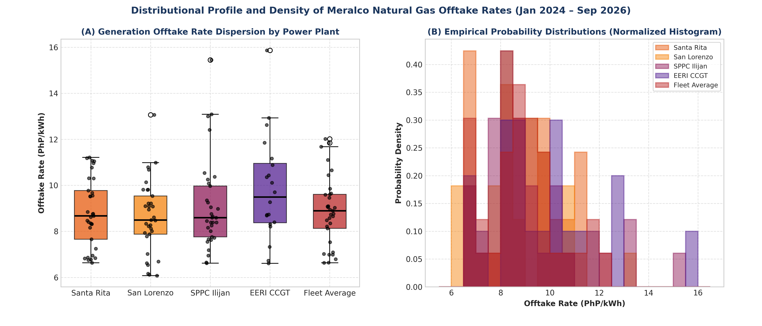
Figure 5: Distributional Profile and Probability Density of Meralco Natural Gas Offtake Rates

7. Multi-Asset Cross-Correlation Heatmap & Public Indexation Comparison
To provide a comprehensive cross-asset perspective, Figure 6 presents the full 9×9 Pearson Linear and Spearman Rank correlation matrices across all four power generating stations and all four public commodity markers. In addition, Table 6 synthesizes the regulatory and econometric suitability of each global marker for Philippine natural gas tariff indexing.
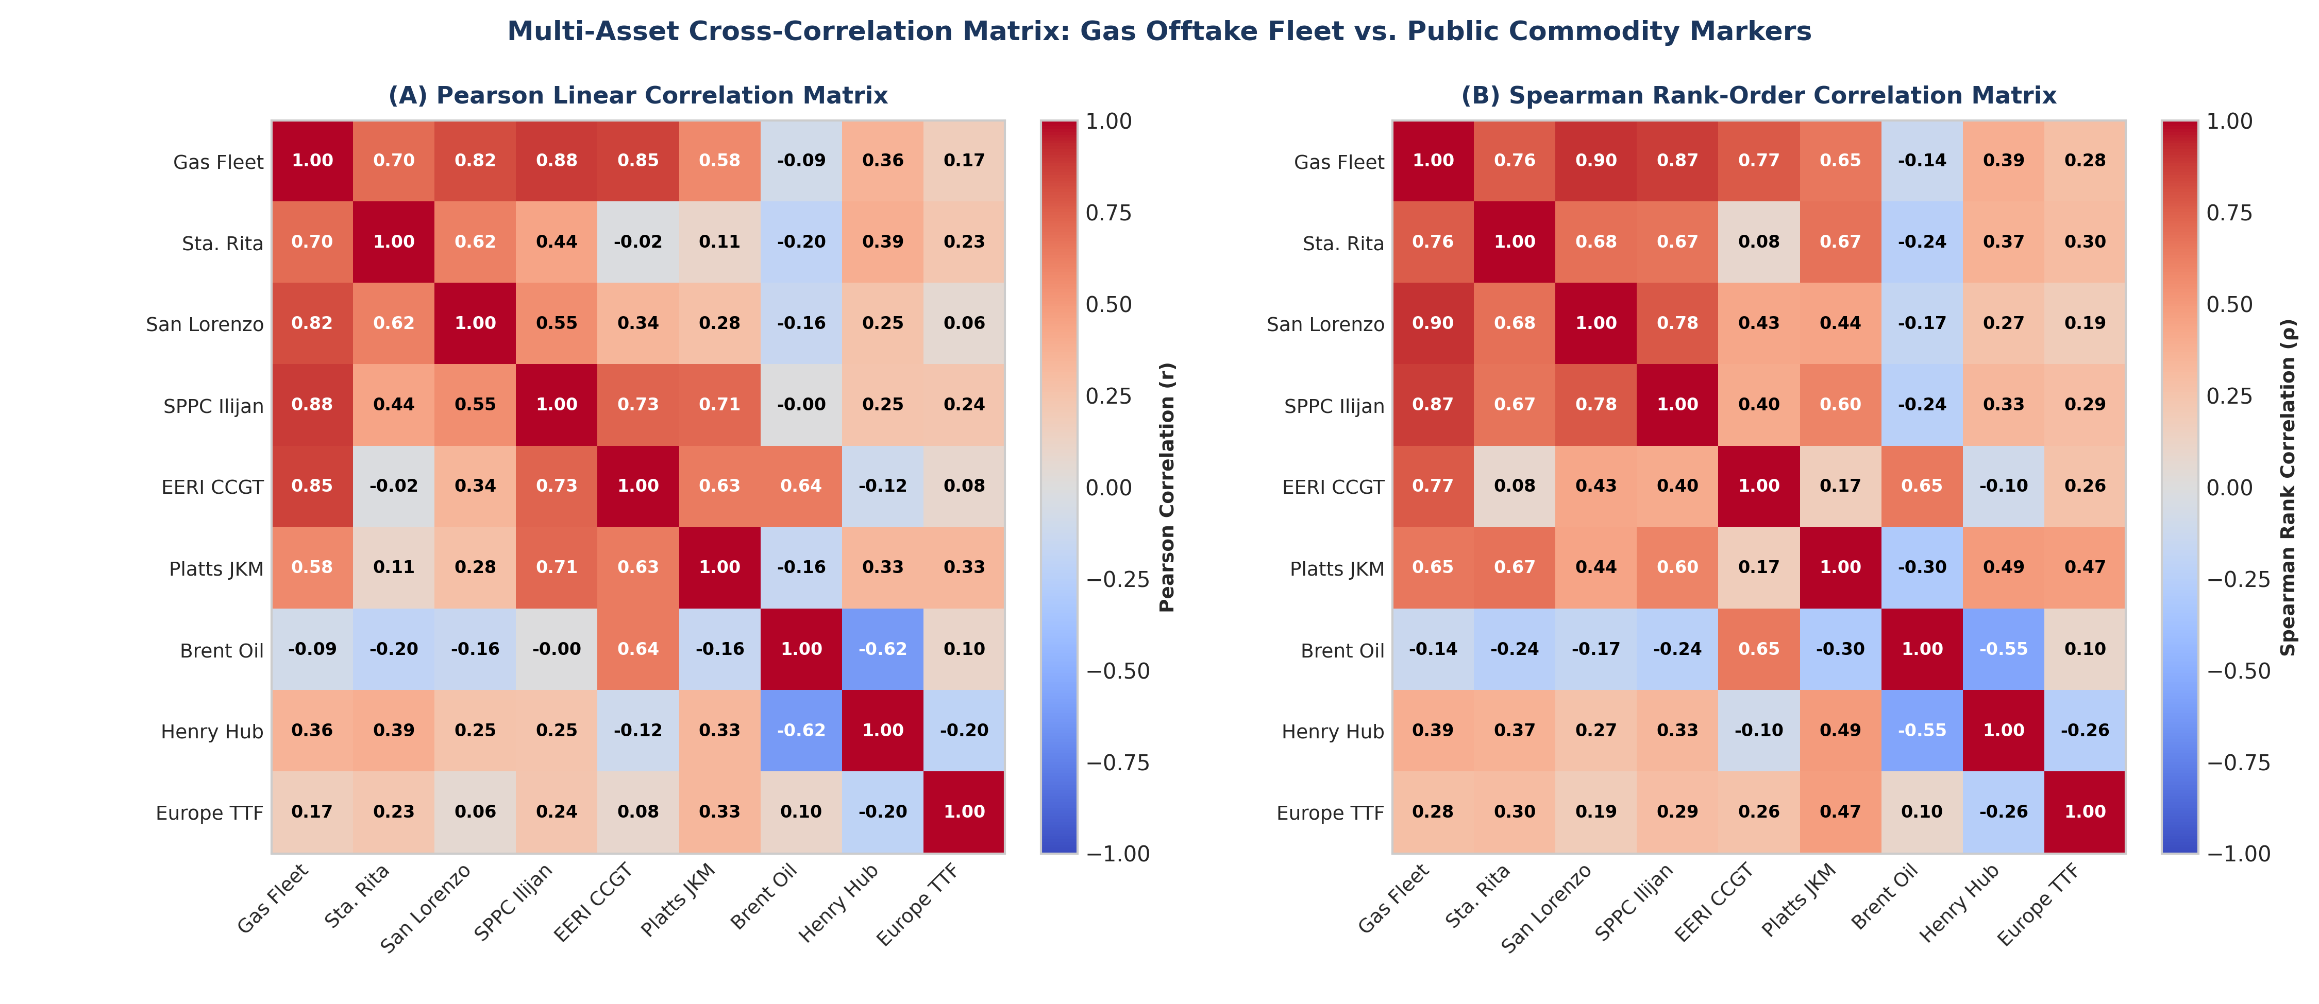
Figure 6: Multi-Asset Cross-Correlation Matrix: Gas Offtake Fleet vs. Public Commodity Markers
Table 6: Public International Commodity Marker Comparison Matrix for Gas Regulation
Commodity Benchmark | Market Scope & Liquidity | Empirical Fit with PH Fleet | Regulatory Suitability & Policy Role
S&P Global Platts JKM (Japan Korea Marker) | Primary spot LNG price benchmark for delivered cargoes into Northeast Asia / Pacific Basin (Investing.com: JKMc1). | Strongest correlation (r = +0.576, R² = 0.332, and r = +0.633 for spot plant EERI). Tracks physical cargo pricing. | Highly Recommended as the primary reference index for imported LNG fuel cost pass-through and GATP benchmarks.
World Bank Brent Crude (Oil Parity / JCC Equivalent) | Global sea-borne crude oil benchmark; historic basis for long-term oil-indexed Asian LNG contracts (Investing.com: BZ). | Negative correlation (r = -0.342, R² = 0.117). Decoupled as global oil eased while domestic gas rose. | Not recommended for spot LNG pricing; useful only as a secondary check for legacy long-term oil-linked contracts.
European TTF Gas (Title Transfer Facility) | Primary continental European pipeline and LNG pricing hub; high liquidity and financial depth (Investing.com: TFM). | Weak correlation (r = +0.095, R² = 0.009). Reflects Atlantic basin balances and European storage levels. | Supplementary benchmark only; useful for global macro risk monitoring during extreme international supply shocks.
US Henry Hub (NYMEX) (North American Pipeline) | US domestic interstate pipeline natural gas benchmark at Erath, Louisiana (Investing.com: NG). | Zero correlation (r = +0.024, R² = 0.001). Isolated US domestic market fundamentals. | Unsuitable as a direct pricing proxy for delivered Asian LNG; reflects US domestic supply rather than landed Asian costs.

8. Strategic Regulatory Conclusions & Policy Recommendations
Based on this comprehensive 33-month empirical econometric and forensic audit of Philippine CCGT offtake rates, public global commodity markers, landed terminal logistics structures, and the Capped Landed Logistics Cost (CLLC) framework, we present the following strategic conclusions and recommendations for energy policymakers, regulators, and distribution utilities:
1. Adopt Platts JKM as the Primary Public LNG Benchmark: The empirical data proves that Platts JKM spot LNG is the only public marker exhibiting strong, statistically significant positive correlation (r = +0.576, p < 0.001) with Philippine natural gas generation tariffs. Power supply agreements and auction ceiling methodologies (such as the Gas Auction Threshold Price / GAIR Rules) should formally benchmark imported LNG commodity costs to Platts JKM on a multi-month trailing average basis (e.g., 3-month trailing average) to smooth short-term cargo volatility.
2. Formally Promulgate and Enforce the CLLC Benchmark Cap (ERC GAIR Section 17 & Resolution 2): The empirical evidence demonstrates that PhP 48.65 Billion in landed terminal fees was passed to consumers over 33 months, of which PhP 27.20 Billion represented unconstrained excess overcharges across Santa Rita (PhP 9.90B), San Lorenzo (PhP 5.00B), SPPC Ilijan (PhP 6.40B), and EERI (PhP 5.90B). The Energy Regulatory Commission (ERC) must formally mandate the Capped Landed Logistics Cost (CLLC) of PhP 0.5353 to PhP 0.5994/kWh ($1.50/MMBtu all-in cap) in Resolution 2 and GAIR Rules, eliminating volumetric dilution and saving consumers PhP 0.70 to PhP 2.30/kWh.
3. Mandate a 0.10%/day Boil-Off Gas (BOG) & Shrinkage Cap: Regulators must eliminate the practice of passing through 100% of cargo holding losses, which added PhP 6.25 Billion to consumer bills. A binding cap of 0.10% per day (or 0.05% for modern onshore storage) should be enforced within the CLLC framework, requiring terminal operators and fuel suppliers to absorb any excess holding losses arising from delayed dispatch or commercial scheduling decisions.
4. Prohibit Unregulated Affiliated Transfer Markups: Terminal transactions between affiliated generation companies and terminal operators (which contributed PhP 2.80 Billion in pass-through markups) must be subjected to rigorous cost-of-service prudency audits. Any intra-group trading margins or transfer pricing markups above verified operating costs must be disallowed from retail generation pass-through.
5. Reject US Henry Hub and Oil-Linked Indexation for Asian Spot LNG: Regulatory frameworks must formally reject US Henry Hub as a direct pricing proxy, as empirical correlation is zero (r = +0.024). Furthermore, legacy Brent crude oil indexation should be phased out for imported spot LNG, as oil markers showed negative correlation (r = -0.342) and failed to reflect Pacific basin supply-demand balances.
6. Standardize Heat Rate Performance Standards: Enforcing a rigid Combined-Cycle Net Heat Rate cap (e.g., 6,100 BTU/kWh under DOE TOR / 6,830 BTU/kWh standard) ensures that thermal efficiency degradation during mid-merit cycling operations is managed by generators rather than passed through as unhedged fuel costs to retail electricity consumers.

